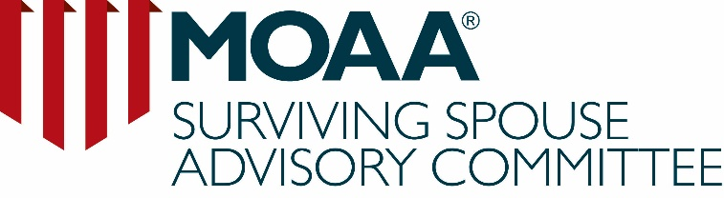

Selection Criteria:
New Surviving Spouse Advisory Committee (SSAC) Members

Mission: To represent the interest of all surviving spouses of MOAA

REQUIRED for consideration
- Current membership in MOAA National
- Surviving spouse of a uniformed service officer
- Ability to participate in annual “Storming the Hill” event, which may require walking and standing for extended periods of time
- Demonstrated commitment to MOAA’s issues for service members, families, veterans, and survivors
- Participates in local chapter and/or state council programs and activities

Selection Criteria

Leadership ability, with the talent to work independently and as a team
- Lead and manage a project from beginning to end
- Generate ideas
- Assume responsibility
- Adhere to deadlines
- Demonstrate excellent people and networking skills
- Visit legislative offices on Capitol Hill to educate members of Congress on issues affecting the military community

Excellent communication skills
- Establish/maintain contact, primarily via e-mail, with both council and chapter presidents and liaisons within the assigned SSAC region
- Maintain awareness of legislative issues impacting surviving spouses
  - Ability to share knowledge
- May contribute articles on a variety of topics for distribution or publication
- Comfortable speaking in front of large and small audiences
- Computer skills include:
- Basic e-mail usage
- Microsoft Word and Excel
- Social media: Facebook, Twitter

Willing to commit significant amounts of time to SSAC
- Available to travel two to three times per year for 3-5 days at a time
- assume a four year term on the committee starting
October 2018, with the option to extend for two years
- Participate in conference calls
- Can commit to work on SSAC business as needed
- New SSAC member will be mentored by a senior member with the expectation that the new member will do the same during committee term

SURVIVING SPOUSE ADVISORY COMMITTEE NOMINATION FORM
Chapter/Council Leader Nomination (Parts A, B, and C Required)

Self-Nomination (Parts A and C Required)

PART A: Nominee Information
Name:
Mailing Address:

Phone Number:
Email Address:
Date of Birth: MOAA National Member Number:
Name of Chapter and/or Council in which currently active:

PART B: Nomination Submitted by Chapter/Council Leader
Chapter/Council Name:
Your Name:
Your Email Address:
Your Current Leadership Position within the Chapter/Council:

PART C: This form must be submitted with the following documentation for the nomination to be considered
- Brief bio of the nominee (no more than 250 words)- should include MOAA involvement, participation in and commitment to MOAA
- At least one letter of endorsement/recommendation from the Chapter or Council President

- The nominee must submit a personal statement on why they want to serve on the committee (this is required regardless of self-nomination or chapter/council leader nomination)

Submit nominations (to include the required documentation) by email to sscomm@moaa.org no later than MAY 31, 2018.

