In this issue:
- Chapter item 1
- Chapter item 2
From National MOAA
Start Your 2026 Strong With MOAA and GNC
From MOAA’s Chairman: Building on Strength
Chapters – enter title of your first news item here
You can use the first part of this newsletter template for your Chapter news to include any meeting recaps or agendas, local news, state legislative issues, and other matters for your members. Please replace “Chapter item 1” above with an applicable topic title.
Chapters – enter title of your second news item here
You can enter your second news item here and if you have any additional items you can copy the formatting and style for any other information you would like to share.

Start Your 2026 Strong With MOAA and GNC
By MOAA Staff

Have you resolved to get fit, or stay fit, in the new year? An upcoming webinar can help you keep that promise.

GNC, a proud sponsor of TotalForce+, will host a 90-minute online event Jan. 7 at 7 p.m. Eastern on healthy aging. The webinar will explore practical, science-based strategies to support energy, strength, and overall wellness.

[ACCESS THE WEBINAR | (Event ID: 927 0739 2710; Passcode: 820623)]

Attendees will:
- Learn how to set health and fitness goals for the year ahead.
- Understand how vitamins and supplements can boost your wellness journey.
- Discover simple tips and tricks to increase mobility and maintain muscle tone.

Healthy aging is about building habits that help you stay active, energized, and resilient at every stage of life. This free webinar is open to the entire uniformed services community – including currently serving members, retirees, veterans, military family members, and survivors.

If you’re ready to invest in your long term wellness, this is a great place to start. GNC operates stores at 85 military installations and provides a 10% discount to servicemembers, dependents, and veterans at retail stores and online.

Don’t miss this chance to make your fitness resolution stick for 2026 – join the free event on Jan. 7 using the link and access information above.
From MOAA’s Chairman: Building on Strength
By: Thomas Waldhauser

As your chairman, I am so proud of what MOAA continues to accomplish on behalf of the entire uniformed services community. Every day, MOAA’s members, volunteers, and staff demonstrate that commitment through advocacy, outreach, and action.

In 2025, MOAA sharpened its legislative strategy with clear priorities and disciplined strategies that continue in the new year. Our Government Relations team has been hard at work on Capitol Hill — building new relationships and strengthening existing ones across the new Congress.

Our Advocacy in Action event once again brought MOAA members from across the country to Washington, D.C., to meet directly with lawmakers — an impressive demonstration of unity and professionalism that continues to set us apart.

[TAKE ACTION: MOAA's Legislative Action Center]

Our grassroots network remains one of the strongest in the nation; amplifying our message through our constituent contacts makes a real difference in legislative outcomes.

We were named in The Hill’s “Top Lobbyist” list for the 19th straight year, a mark of our sustained influence and the trust in our advocacy.

[RELATED: MOAA Charities]

That same spirit of service was on full display at our inaugural TotalForce+ conference, where leaders from across the uniformed service, civilian, industry, and academic sectors came together to strengthen the all-volunteer force. The conversations and ideas shared there will shape our efforts in the years ahead, including as we look toward a number of smaller TotalForce+ events in 2026, with the full conference returning Feb. 1-3, 2027.

Please share the good work of our association throughout your network and in your local communities. Remind potential members of our greatest achievements.

From a personal perspective, I find my service on this board over the past five years, and especially now as your chairman, incredibly rewarding and
gratifying. I want to express my gratitude to MOAA’s dedicated council and chapter leaders, staff, and every member and volunteer who keeps our association strong. Your leadership, advocacy, and generosity drive our success.

Together, we will continue to protect what’s been earned, champion solutions that strengthen the community we serve, and advance a future worthy of those who defend our nation.

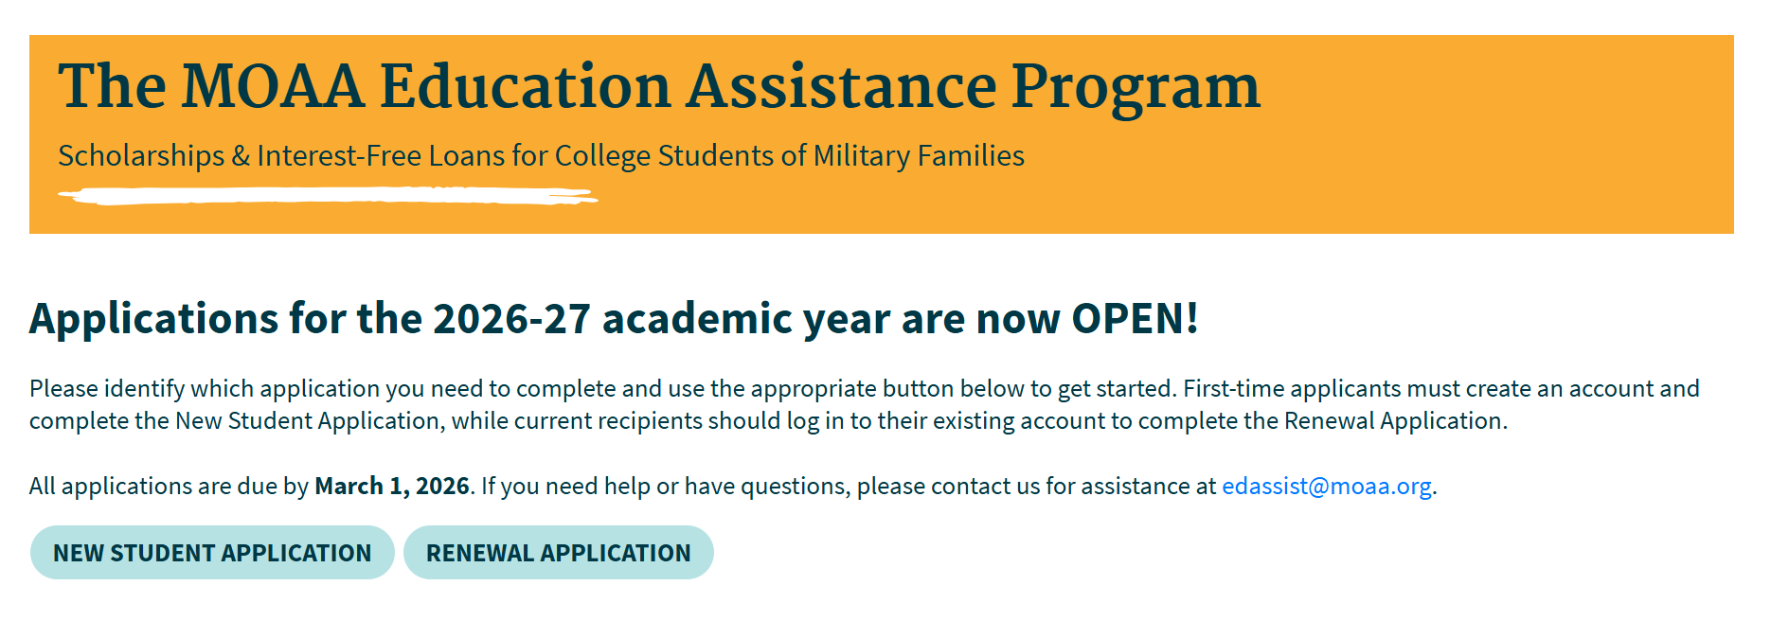

Access the Application Portal
We use SurveyMonkey Apply to facilitate our application process. While applications are only open from Nov 1 to March 1, you can access your account at any time to check the status of your application.

Chapters – enter title of an interesting news item here
Provide pictures and stories of a recent chapter meeting or program
You can copy and paste your Chapter news source “then site the news source (i.e. person’s name and/or where you pulled that source)”; you can include any items of interest, special programs, dates of your next meeting, recaps or agendas, local news, state legislative issues, and other matters for your members.

Chapters – enter title of your final news item here
This item should conclude or wrap up your newsletter; next, provide chapter’s contact information for officers, RSVP meeting (easy return form) for special meetings you mentioned, and/or chapter enrollment form for new members.

