In this issue:
- Chapter item 1
- Chapter item 2
From National MOAA:
MOAA Resources: Health Care
Transition and Career

Chapters – enter the title of your first news item
You can use the first part of this newsletter template for your Chapter news to include any meeting recaps or agendas, local news, state legislative issues, and other matters for your members. Please replace “Chapter item 1” above with an applicable topic title.

Chapters – enter the title of your second news item
You can enter your second news item here and if you have any additional items you can copy the formatting and style for any other information you would like to share.

MOAA-Backed Caregiver Bill Takes Major Step Forward in House
By: René Campos
February 17, 2026
Bipartisan legislation that would provide much-needed support to veteran caregivers took a significant step toward becoming law last week, advancing out of the House Veterans’ Affairs Committee alongside other important MOAA-supported bills.
The progress of the Veteran Caregiver Reeducation, Reemployment, and Retirement (3R) Act (H.R. 2148) highlights growing bipartisan commitment to strengthening support for caregivers, families, and some of the most severely wounded, injured, and disabled veterans in the country.
[TAKE ACTION: Ask Your Lawmakers to Support Veteran Caregivers]
The legislation represents a major step forward for the caregivers who form the backbone of veterans’ long-term care. By expanding access to education, easing reemployment barriers, and enhancing retirement planning resources, the bill helps ensure caregivers have the tools they need to maintain stability while supporting those who served.
Without targeted reforms like those in the 3R Act, caregivers could be left to rely on public assistance, shifting costs between government agencies rather than reducing them.
MOAA is grateful to every member and veteran advocate who contacted their lawmakers urging action on this critical measure. Your engagement made a real difference. Now that the bill has passed out of both the House and Senate Veterans’ Affairs Committees, it is more important than ever to keep the pressure on this priority. We encourage you to continue urging your elected officials to bring H.R. 2148 and S. 879 to the floor in both chambers and ensure it becomes law before the end of this year.
The legislation will be a key part of MOAA’s upcoming testimony before a joint Feb. 24 hearing of the House and Senate Veterans Affairs Committees. That testimony will cover a range of veterans’ priorities, such as protecting veterans from unaccredited “claim sharks” via the Governing Unaccredited Representatives Defrauding (GUARD) VA Benefits Act and ending the “wounded veteran tax” faced by tens of thousands of combat-injured veterans via the Major Richard Star Act.
More Bills Move Forward
Along with the 3R act, House Veterans Affairs Committee members advanced other MOAA-supported legislation in their Feb. 12 hearing:
- The Fisher House Availability Act (H.R. 3726), which would allow TRICARE beneficiaries, including active duty families, to stay in VA Fisher Houses on a space-available basis. This change would expand access to lodging for families traveling for specialty or emergency care, reducing financial strain and ensuring they can remain close to their loved ones during treatment.
- The Sharri Briley and Eric Edmundson Veterans Benefits Expansion Act (H.R. 6047), which would increase the rate of Dependency and Indemnity Compensation (DIC) to provide additional financial support for survivors and increase the rate of Special Monthly Compensation (SMC) to boost financial support for catastrophically service-connected disabled veterans. The bill is named for Sharri Briley, widow of an Army Black Hawk pilot killed in Somalia in 1993, and for Eric Edmundson, a former Army sergeant who suffered shrapnel wounds, a heart attack, and a brain injury after his Humvee struck a roadside bomb in Iraq in 2005.
Your Advocacy Remains Essential
The hearing delivered meaningful momentum, but much work remains to get MOAA’s legislative priorities across the finish line. MOAA urges all members and supporters to continue contacting their lawmakers to ensure these bills move swiftly to the floor and are enacted into law. Add your voice to our cause via our Legislative Action Center.
MOAA will continue to monitor developments closely and keep you informed as these important measures progress.

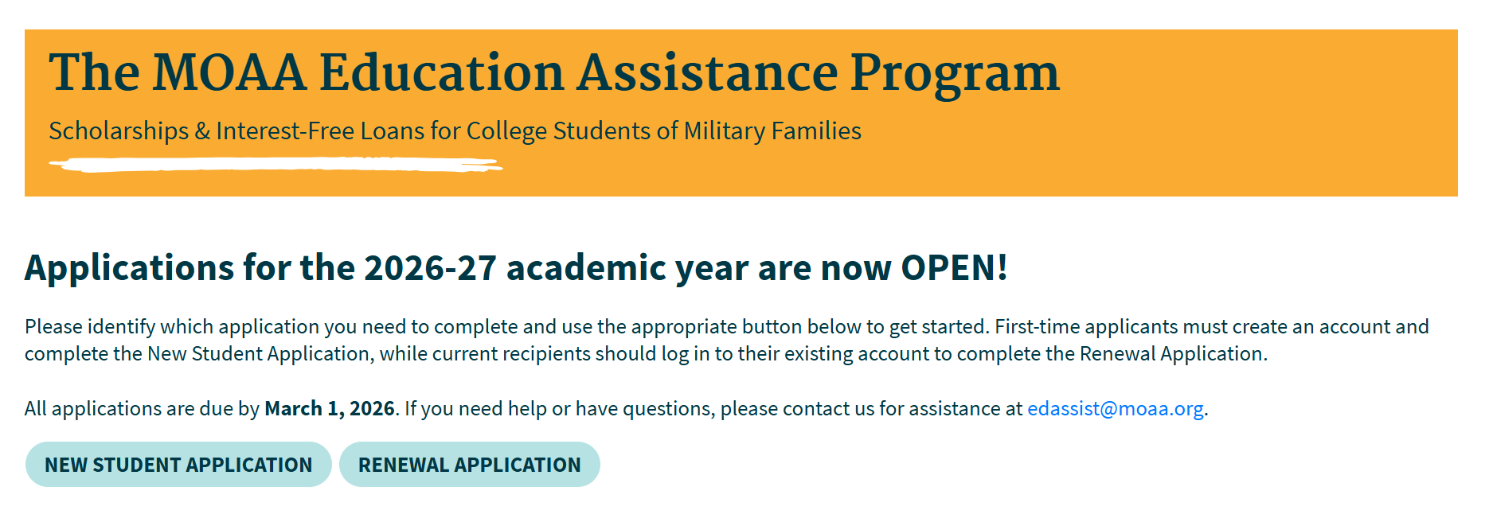

Access the Application Portal
We use SurveyMonkey Apply to facilitate our application process. While applications are only open from Nov 1 to March 1, you can access your account at any time to check the status of your application.

Chapters – enter title of an interesting news item here
Provide pictures and stories of a recent chapter meeting or program
You can copy and paste your Chapter news source “then site the news source (i.e. person’s name and/or where you pulled that source)”; you can include any items of interest, special programs, dates of your next meeting, recaps or agendas, local news, state legislative issues, and other matters for your members.

Chapters – enter title of your final news item here
This item should conclude or wrap up your newsletter; next, provide chapter’s contact information for officers, RSVP meeting (easy return form) for special meetings you mentioned, and/or chapter enrollment form for new members.

